**DevOps Overview & Source Code Management**

**Lab File :**



**School of Computer Science**

**UNIVERSITY OF PETROLEUM AND ENERGY STUDIES**

**Submitted by: Submitted to:**

Name : Amartya kumar Dr. Arjun Arora

Sap Id : 500097356

Roll No : R2142211335

Batch : 4

Subject code : CSDV 2104



Experiment 1. Introducing Version Control (GIT)

The method of managing changes to software code is known as version control, commonly referred to as source control. Software technologies called version control systems assist software development teams in tracking changes to source code over time. Version control systems enable software teams to operate more swiftly and intelligently as development environments have increased. They are especially helpful for DevOps teams because they enable them to speed up successful deployments and cut down on development time.

Every change to the code is recorded by version control software in a particular form of database. If a mistake is made, programmers can go back in time and review prior iterations of the code to help fix it while causing the least amount of interruption to the entire team.



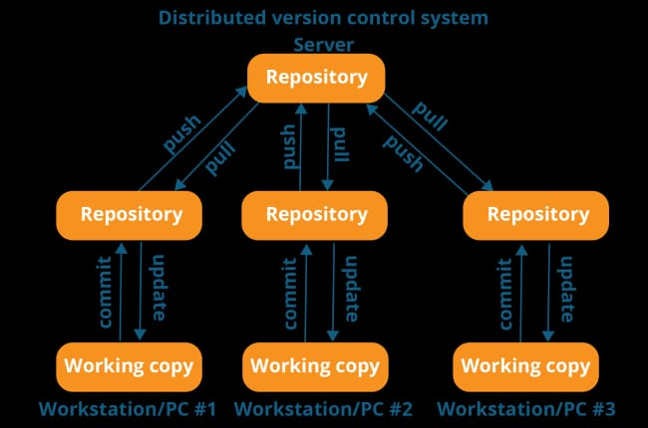

EXPERIMENRT 2. Installing/Create Profile GitHub and Git Bash.

Installing :

* Go to browser and search for Download/Install Git
* Download the file according to your system configuration.
* Then install it in your system.

Here are some screenshots while installing Git

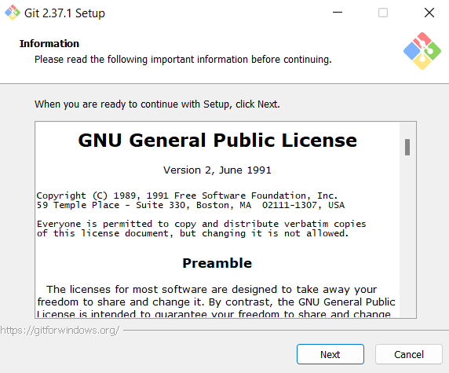 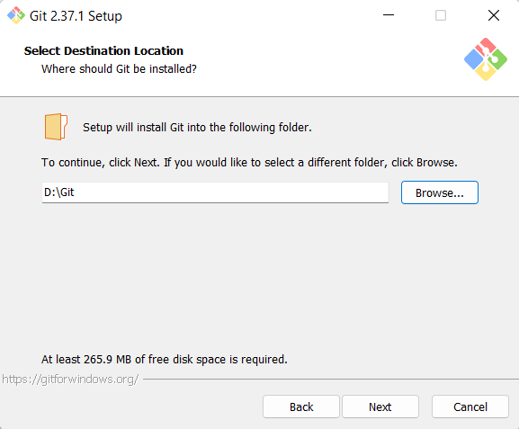

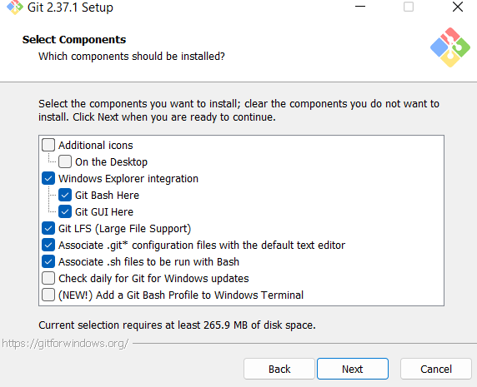 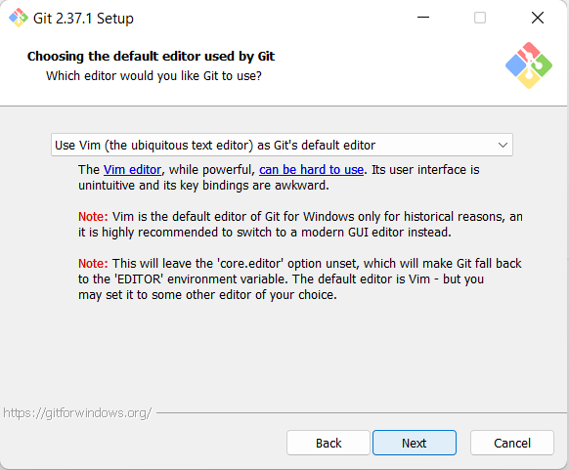

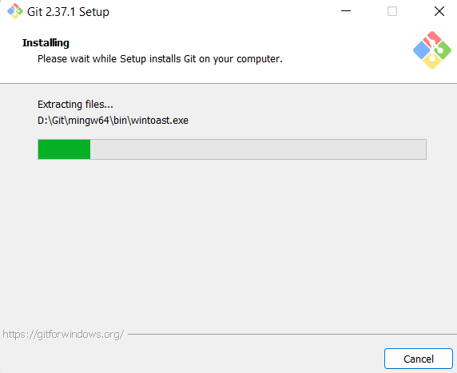

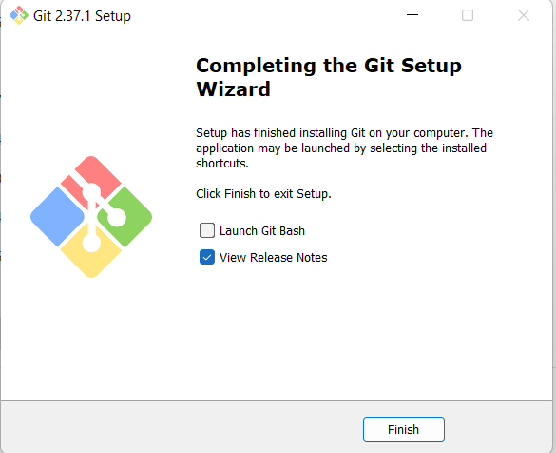

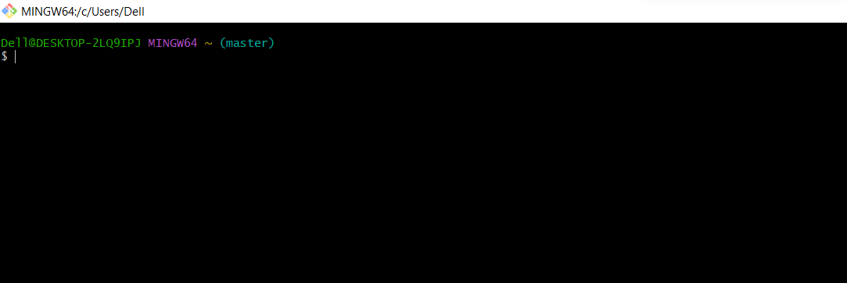

**.** Go to browser and search for download Git-hub

**.** install Git-hub

**.** Fill your data for id making

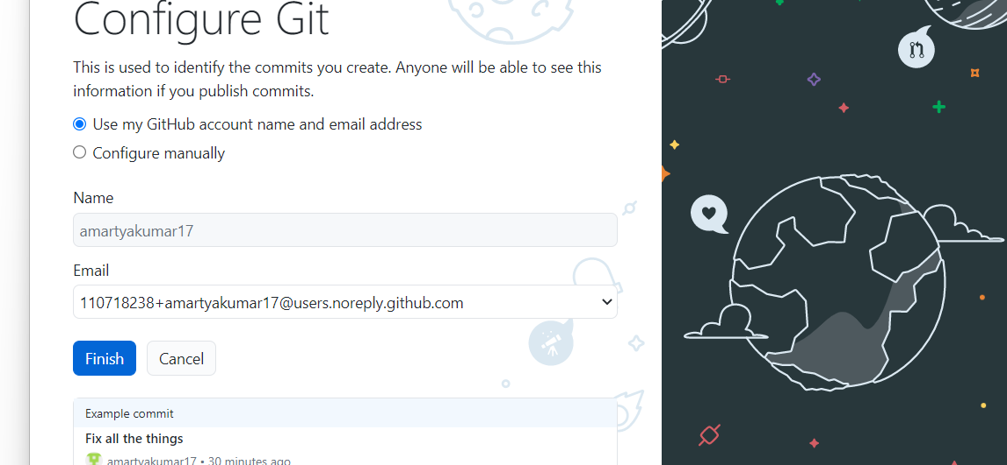



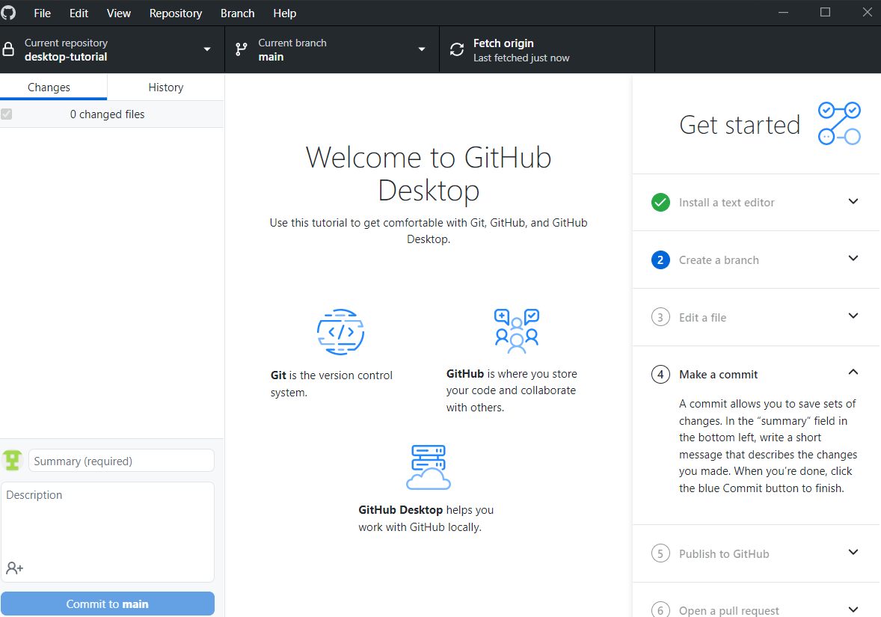

Experiment 3. Exploring basic command on Git

